Strayer University

INVENTORY MANAGEMENT SYSTEMS

Week 2

Assignment 1

for the

Course of

Systems Analysis and Development

4/17/2017

By

Kennedy Kabaso.

Professor: Irene Hoskins.

**INVENTORY MANAGEMENT SYSTEMS**

**Introduction**

Last year, I went to see my Mother whom I had not seen for fifteen year in Africa. It was one of my most memorable moment in my life. I had to fly for fourteen hours which was one of my longest flights I have ever had. I was kind of scared because we were on the ocean for twelve hours. I was very happy to be there which made my family to have a big dinner. During a dinner, my sister Veronica, who has a small clothing store expressed her frustration about having to manually track and reorder items which were on high demand. She told me if I could create a plan for a low-cost automated inventory system which can meet her small budget. I told her I would try my best by using all the best computer skills I have to solve her problem.

Therefore, I arranged to meet her at the store so that I can see how big her space is and give her better advise on how to go about it. I am going to describe the whole process and all the necessary equipment which are required, explain the costs involved in the creation of the system, describe the on-going maintenance that will be required and finally provide a workflow diagram in Visio or equivalent software to illustrate how the system will work.

**Necessary Equipment**

The most impatantant issue was her budget which is very small, therefore I wanted her to get an automated system IQRF which comes with a scanner. This equipment according to an article and I quote “Is an Automated Inventory System which is a wireless communication system for localization, data collection and control for use in the industrial sphere, stores, shops or other places”. Moreover, the IQRF track the position and movement of objects within a given space using IQRF smart transceivers. IQRF transceivers are very powerful identification units which work as two directional wireless communicators. It makes the whole system to be acted by a superior unit which make sure all the objects are kept safe. She will need an HP laptop which costs about $200 with a bigger Ram of 4 Bits, a 500 giga of Hard drive and a duo core processor. The Laptop is where the technician will install the database and will be on the same network with the IQRF. The internet service with a wireless router, which is used to communicate to the whole world and to the equipment that uses wireless is needed. She can have a local internet company called copper net, come to the shop and do the installation. The service is not expensive because there are a lot of internet service provider companies who are competing each other, as a result she can get a high-speed internet service as low as $10 per month. For her to keep up with inventory, she will need a software used to help with the whole system. It can be any cheap software which keeps track of sales order, customers, inventory, purchasing and reports can work well and can cost between $30 and $50. Moreover, updates can be done automatically which makes it better if you have the wireless internet. A regular printer which costs about $150 is a four in one. I mean it has a scanner to scan the document, it copies text and image, it faxes when you need to send a document quickly and finally it prints pages after pages of color black or white text and images.

**Costs**

With all the above-mentioned equipment’s, I would like to explain some of the cost which are necessary. I would start with the IQRF which is the most important equipment of this project. The most important job of the IQRF Automated Inventory System according to an article and I quote “is to take inventory of goods, components, vehicles and other items in a particular space without handwork. Automated methods are much faster and cheaper, while IQRF wireless technology which is built into it makes the equipment more flexible and efficient “. This can reduce the cost of paying someone to monitored it. In additional, it collects data such as change of an object's position, access to an object, status of an object and some important information about the inventorry of things. It has transceivers which can take care of inventoried things and process data which was taken if query. The whole process reduces the work force which is good for the business that can results in more saving of money which can be pumped into the business. The whole budgets can be some few thousands of dollars which is affordable to her. If I put it in numbers, it can cost between $ 1000 and $ 2 000 for the equipment plus the above-mentioned expenses. There is a onetime fee of doing all these tasks which needed to be taken into consideration. She needs to employ two people to do the ground work, the engineer to lay down the equipment, the IT personal to configuration the equipment with the computer and the database which is going to have the inventory and the software. This whole cost of doing these jobs will be about $150 which is a lot for African Labor standards.

**Maintenance**

The maintenance of this equipment is something she doesn't have to worry about as it comes with life time warranty. If it stops working or started giving problems, the manufacture of this will send the engineer to come and fix it without any costs. In addition, every six months, they come to inspect it. The laptop on the other hand, can be restored to a factory level if it stops working properly or slows down. She should open the control panel and search on system restore which will open the system restore wizard, then follow some steps till the end. After finishing doing the restoration, it will reboot and started working the way it was when it was bought. The only thing she needs to keep is the CDs which comes with the software for the inventory. She can start doing the fresh installation for the software using those CDs. And, must take an inventory system training and buying the package for technical support. This will save her some money because she does n't need an information technology personal to do that. The equipments for the internet is taken care of by the internet service provider. Once it stops working, they would replace it with a new one without any extra cost. Most of the money which is supposed to be paying for the maintenance can be put on her training cost which is $150 to finish the whole course.

Finally, the whole process if well done would produce better results for her small business. And I have put the whole process in form of a flow chart to show how the whole process of inventory is going to work which is scan the goods with the equipment, put the number in the database. If there will be any change in the database number of good then, that number is the sales number which will be the number of good needed to be replaced and then update the database with the new supply.

**Flow Chart**

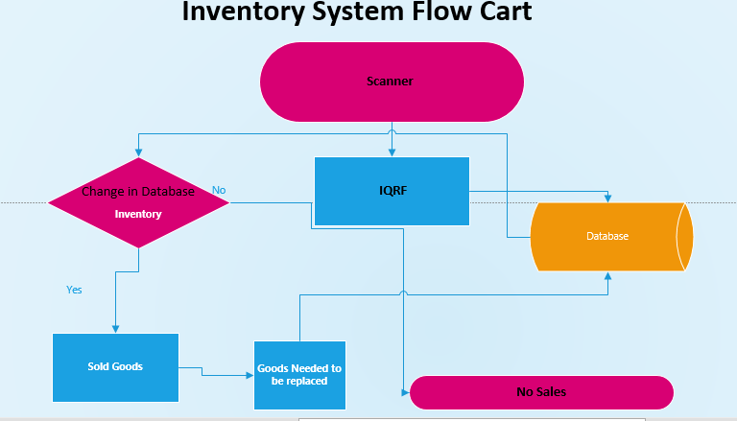

**Citations**

* <http://www.iqrf.org/iqrfabout/case-studies/automated-inventory-system>
* [www.yahoo.com](http://www.yahoo.com)
* [www.bing.com](http://www.bing.com)